FMX Mobile Application Development

Lab Exercise 02.06: Deploying InterBase IBLite Applications to Mobile Devices

Up to this point, we have used the InterBase database on our desktop. This means that the actual database is located on your local hard drive. On the mobile devices, the application is sandboxed, and typically you can only read and write data that is located in the Documents folder for an IOS device and internal storage for an Android device, under your application folder. So to connect to a local database on mobile, we need to perform a few actions. Those actions are:
1. For our mobile devices, we need to deploy both our InterBase IBlite or ToGo database and our InterBase ToGo license file (reg_iblite.txt or reg_intogo.txt).
2. To make this easy for us, we can use Project | Deployment.
3. Select All Configurations - Android platform, and using the Add file button we can add both our InterBase IBlite or ToGo database file and InterBase IBlite or ToGo license file.
Here we see we added our InterBase IBlite database file (using the Add File button), and for the remote path on our mobile device, we set it to the Android’s Documents folder which is the internal storage location for Android, which is .assets/internal. And we do the same for our InterBase IBlite license file and give it the Remote Path of .assets/internal/interbase/license:
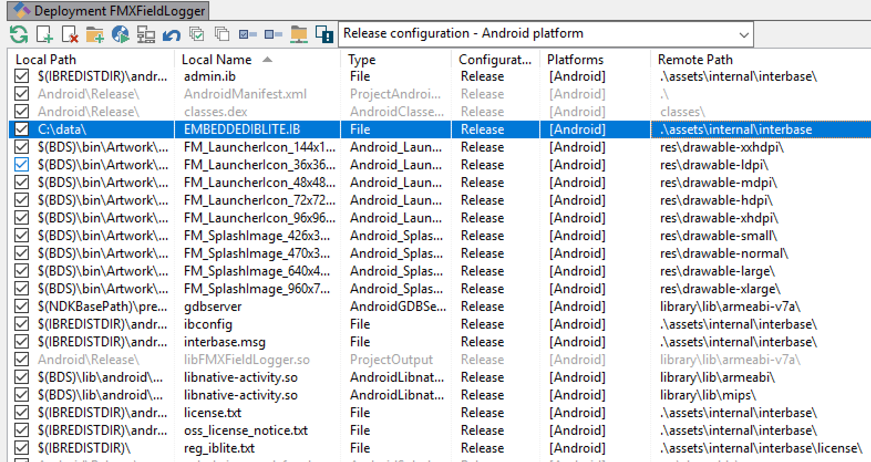

4. And similar for iOS devices, select iOS Devices (32 and 64 bit) ALL Configurations. The InterBase IBlite database file goes in the iOS Device Documents folder using the Remote Path property, which is StartUp/Documents.
5. And the same for the InterBase IBlite license file in the StartUp/Documents folder on the iOS Device.
Deployment Managers | Add Featured File
1. Use the Deployment Managers | Add Featured Files dialog box that shows a nested list of database drivers and libraries that can be added to the deployment list:
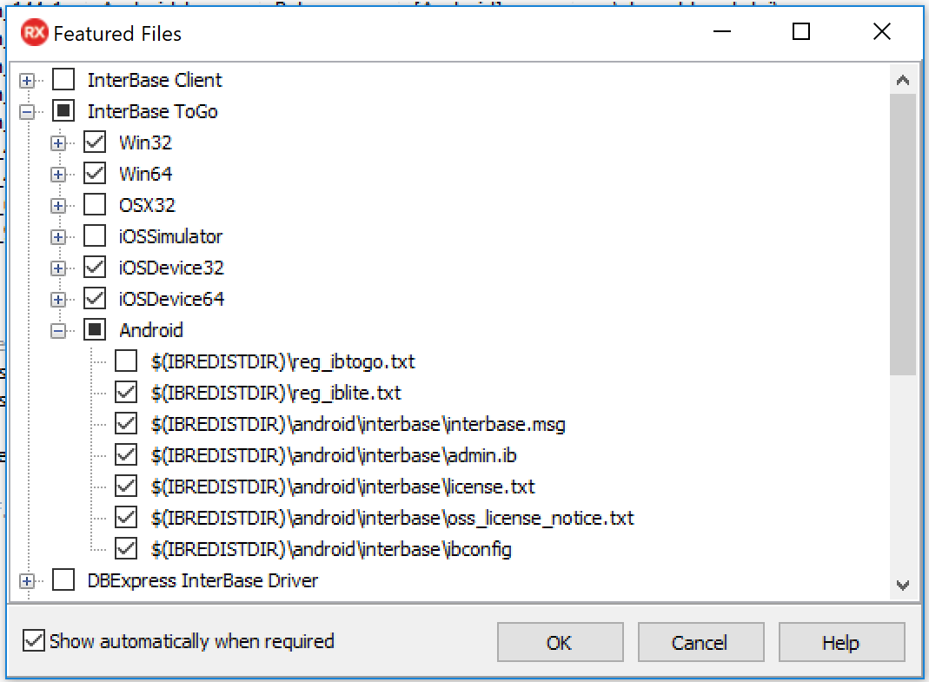
2. Select and add your needed IBlite files for Android and iOS.
3. Deploy your FMX Field Logger application to Android and/or iOS and verify the app works the same as you have been testing on Windows.

